
Student Name:___________________________

Eastern Goldfields College

Applications – Unit 2 - 2017

Investigation 2 – Piecewise and Step Functions

Task weighting: 5% (U2 10%) This investigation is in two parts

Part A Take home – This section is completed for homework and is a preparation activity for the
validation. (0 marks)

Part B Validation - 50 minutes in class, under test conditions, that will test your understanding
of the preparation activities in Part A. Calculator ONLY is permitted. (50 marks)

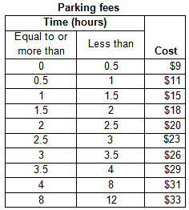
PART A – Preparation Activities

Question 1
The table below shows the schedule for parking fees at a local hospital. The car park is open from 6:00 am to 6:00 pm.

Draw a step graph to represent the data.

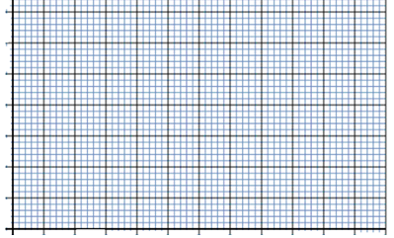

Question 2
In the 2014 Commonwealth games, the triathlon consisted of three stages: a 1500 m swim followed by a 40 km bike ride and then a 10 km run for both the men’s and the women’s events. The winners completed the three stages in the times below.
 | Swim | Cycle | Run
Men’s Event (actual time) | 18 mins | 58 mins 43 sec | 31 mins 9 secs
Time in min (1 d.p.)
Average Speed (km/hr)

 | Swim | Cycle | Run
Women’s Event (actual time) | 19 mins 37 secs | 1 h 4 mins 1 sec | 34 mins 21 secs
Time in min (1 d.p.)
Average Speed (km/hr)

(a) Complete the table and
(i) convert all times to minutes, correct to one decimal place.

(ii) Calculate the average speed (km/h) of the winners on each stage of the triathlon.

(b) On the same set of axes, draw two piece-wise graphs – one for the men’s event and the other for the women’s event - showing the distance covered for the time taken.
Plot “time taken” (in minutes) on the horizontal axis and “distance covered” on the vertical axis.

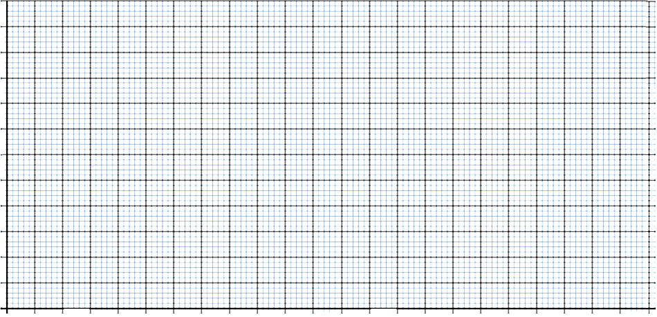

(c) Compare the performance of the two triathletes.

(d) What conclusions can you draw about each winner’s performance on the different stages of the triathlon?

Question 3
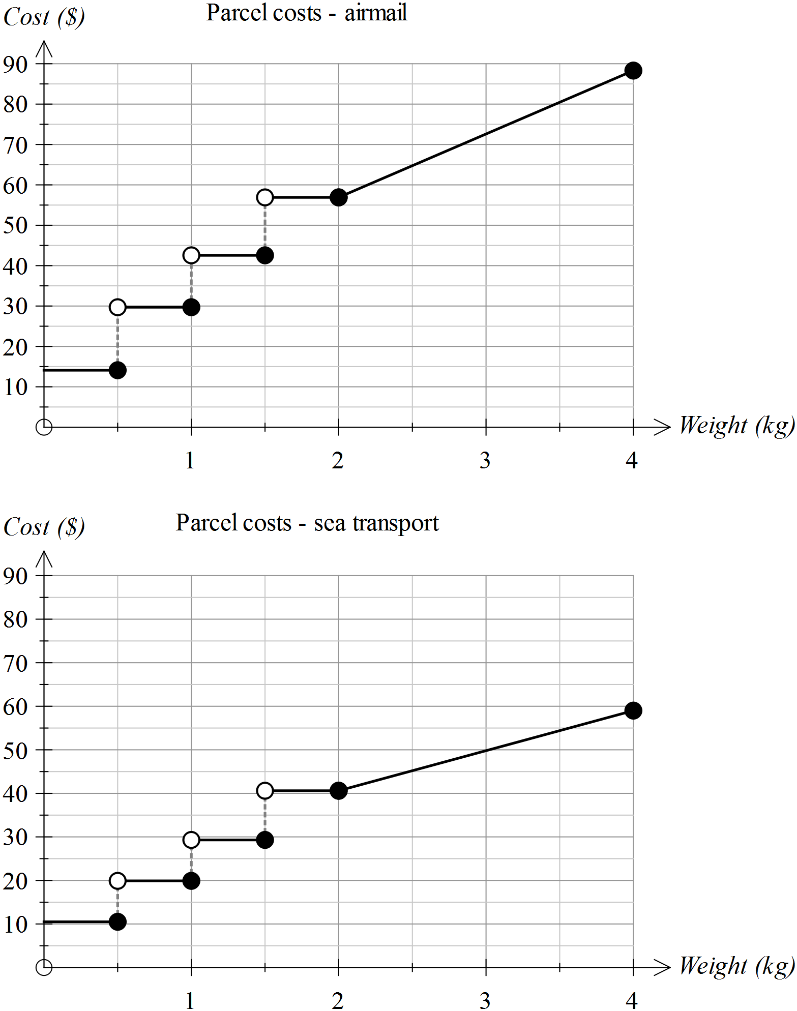The graphs below show the cost of posting parcels to locations overseas in 2014. The first graph is for transport by air and the second is for sea transport.

(a) Use the graphs to determine the approximate costs for sending these parcels.

- A parcel weighing 500 g by air and by sea

- A parcel weighing 1.8 kg by air

- A parcel weighing 1.99 kg by air

- A parcel weighing 3 kg by sea

- A parcel weighing 4 kg by air

(b) Using a different colour, place the data from the second graph onto the first graph. Describe the location of the new graph in relation to the original one.

(c) Consider the following statement.

For the same weight, it is always cheaper to send the parcel by sea than by air

Is this statement always true? How would you know this from the graphs?

(d) There is a change to pricing when the parcel is over 2 kg.

A. The price is set for a fixed range of weights
B. The price increases by a fixed amount per kg

Which of the two statements above applies when the parcel is
(i) under 2 kg in weight
(ii) over 2 kg in weight

(e) What is the approximate cost per kg of sending a parcel overseas by air if the parcel weighs more than 2 kg?

(f) Determine the rate at which the cost changes per kg, when a parcel to be sent overseas by sea, weighs more than 2 kg.

(g) Determine the gradients of the following lines - the lines linking the costs of postage for parcels
(i) sent overseas by air and weighing less than 500 g
(ii) sent overseas by air and weighing over 2 kg
(iii) sent overseas by sea and weighing over 2 kg
(iv) sent overseas by sea and weighing between 1.5 kg and 2 kg

(h) Consider the following change to the cost of sending a parcel overseas by sea transport.

The price will rise by $5 within each range of weights between 0 and 2 kg.
The cost per kg for parcels weighing more than 2 kg will remain unchanged.

Add a new graph to the second graph to reflect this change.

Question 4
The cost of postage for parcels less than 2 kg in weight is displayed as a step graph. Locate at least five other examples of data for which a step graph would be most appropriate.

Question 5
Jon pays his water bill every two months. It consists of a fixed charge for the connection and sewage plus a fee that varies according to the amount of water used. The graph of the pricing schedule is shown below.
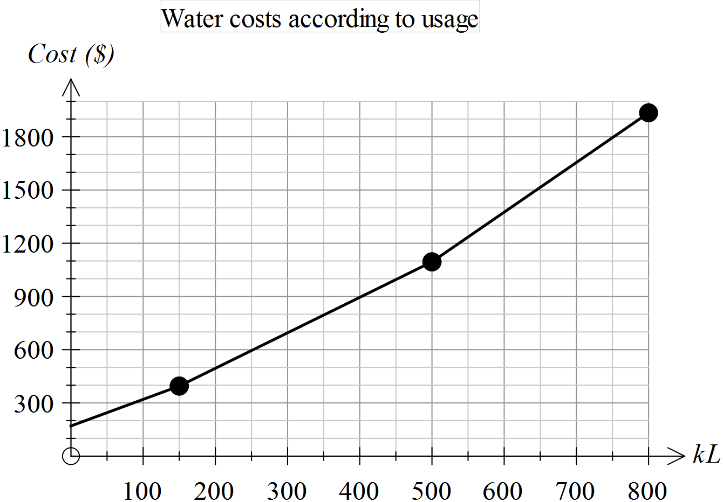
(a) Estimate the total fixed charge.

(b) At what levels of water usage do the rates at which water is charged vary?

(c) Is it true to say that “when the rates vary, they are increasing”? How can you verify your conclusion from the graph provided?

(d) Determine the approximate charges for the following water usages.

(i) 100 kL (ii) 0.25 ML (iii) 650 kL (iv) 50 000 L

(e) Use the graph to determine the rate at which water is charged when the consumption is over 500 kL.

(f) Explain how you can determine the equation of the first section of this piece-wise graph.

(g) The second section of this piece-wise graph has the equation

Cost = 2 x Number of kL + 95

What is the significance of “2” in the equation above?

